web programming  
LAB 9

23BCE1016 Tarun Chebolu

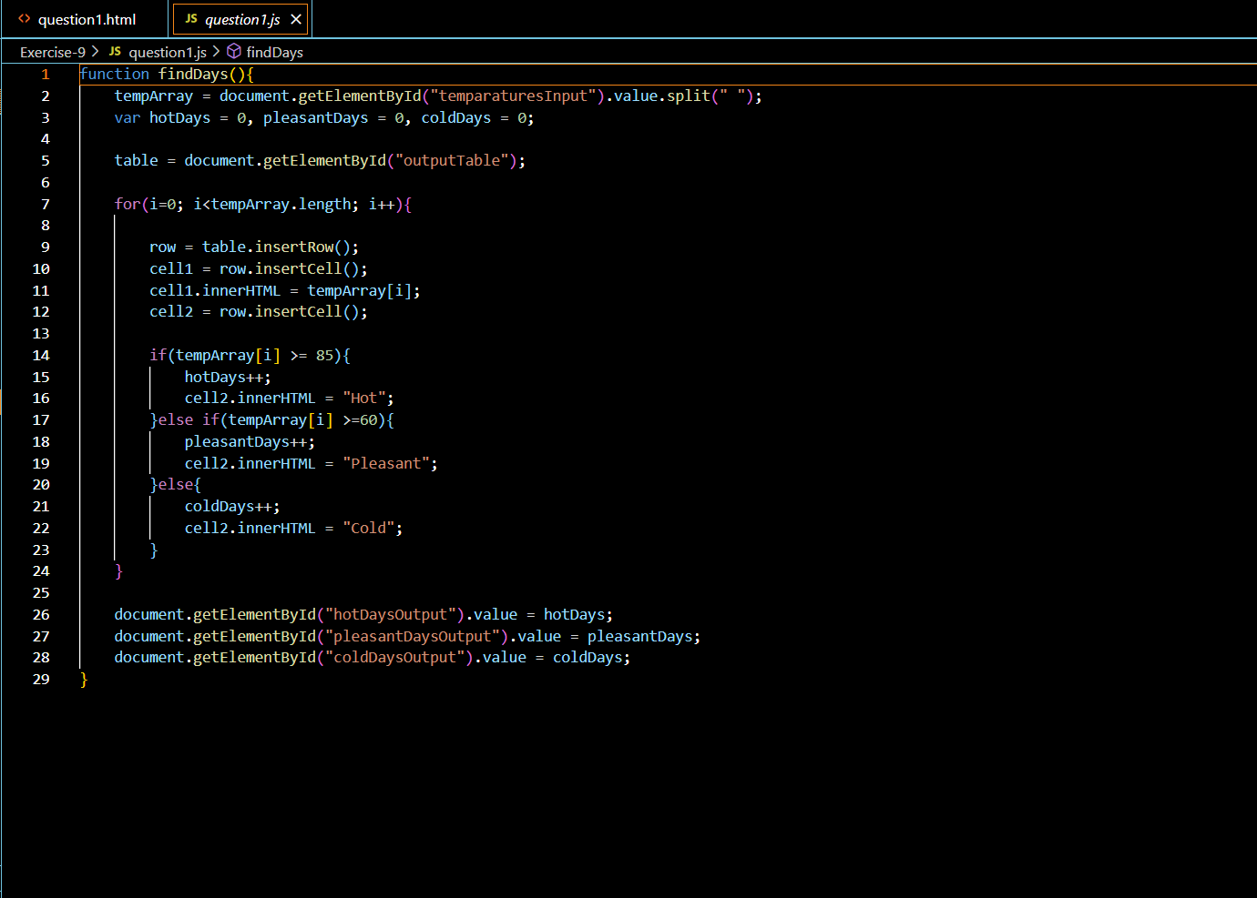

Output

## Question -2

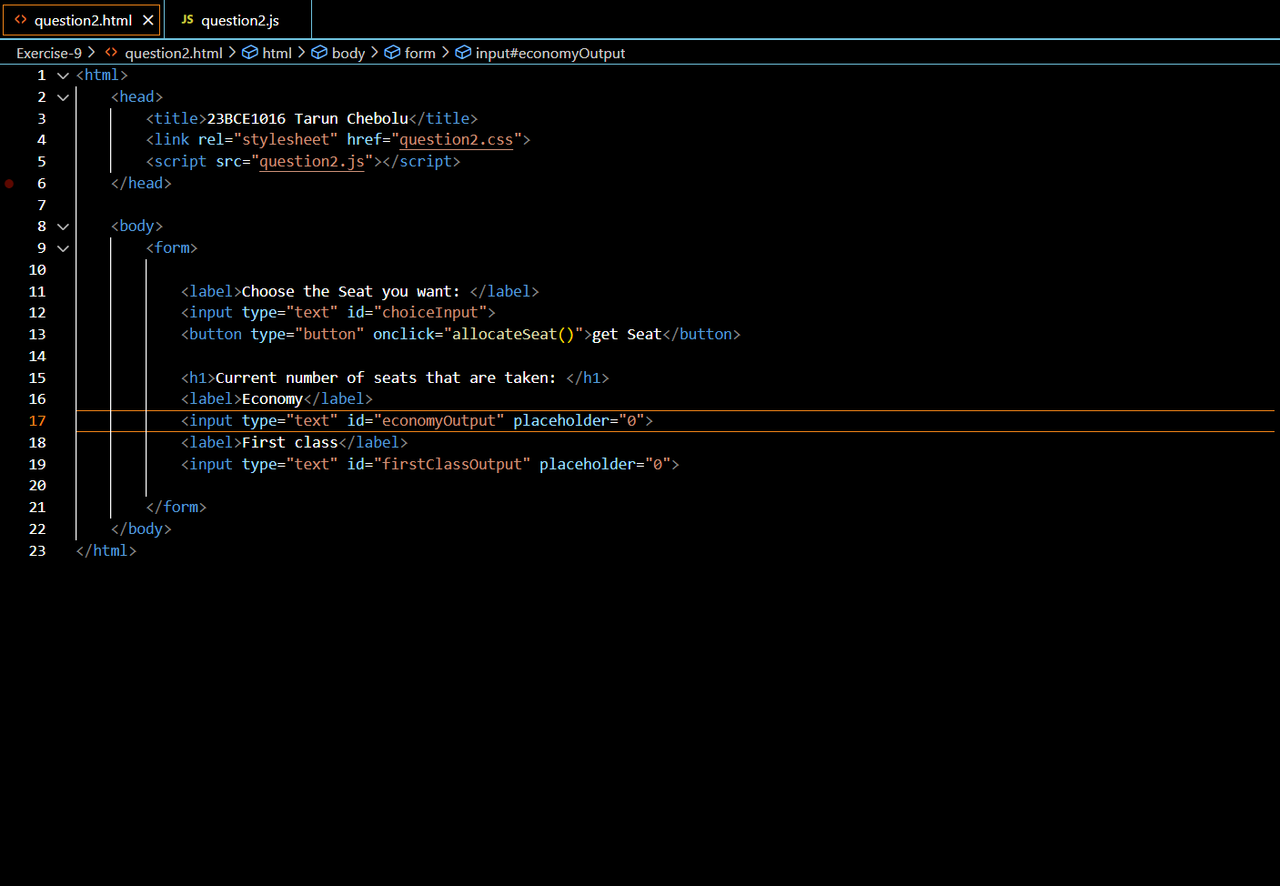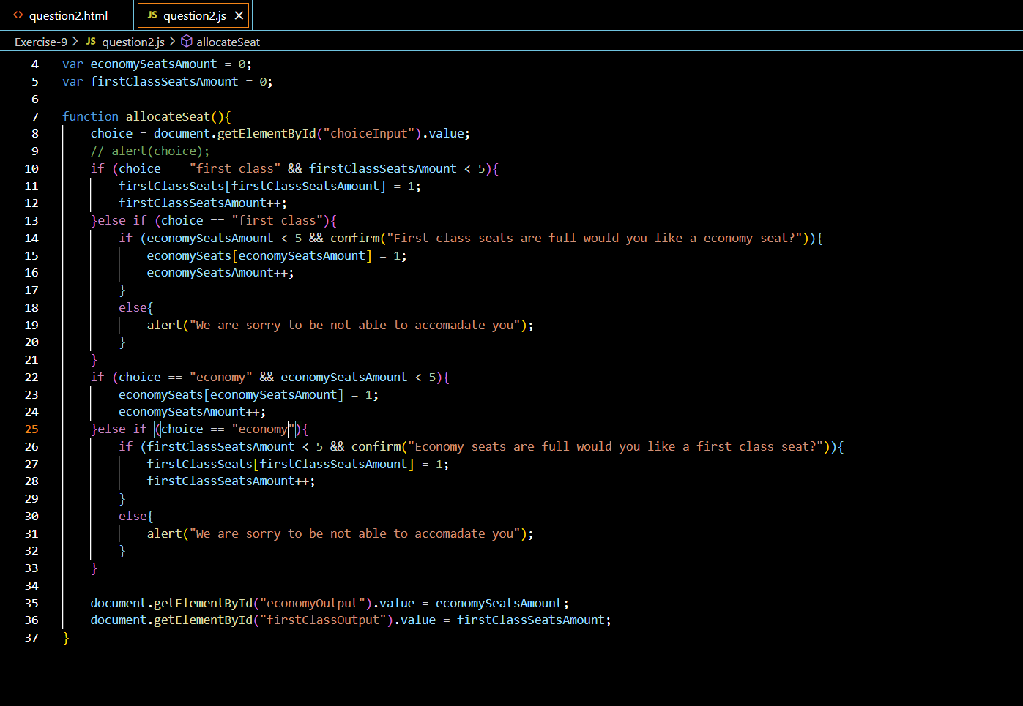

Output

Booking economy

Booking first class

When one of them is full

Pressing “ok”

Pressing “cancel”

## Question -3

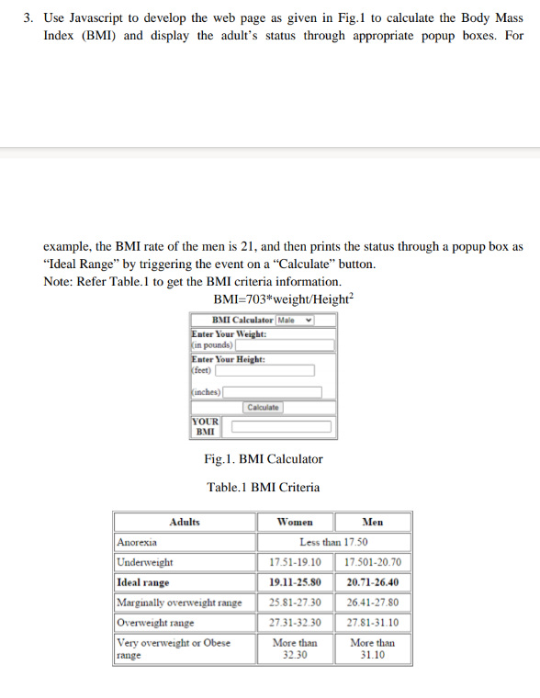

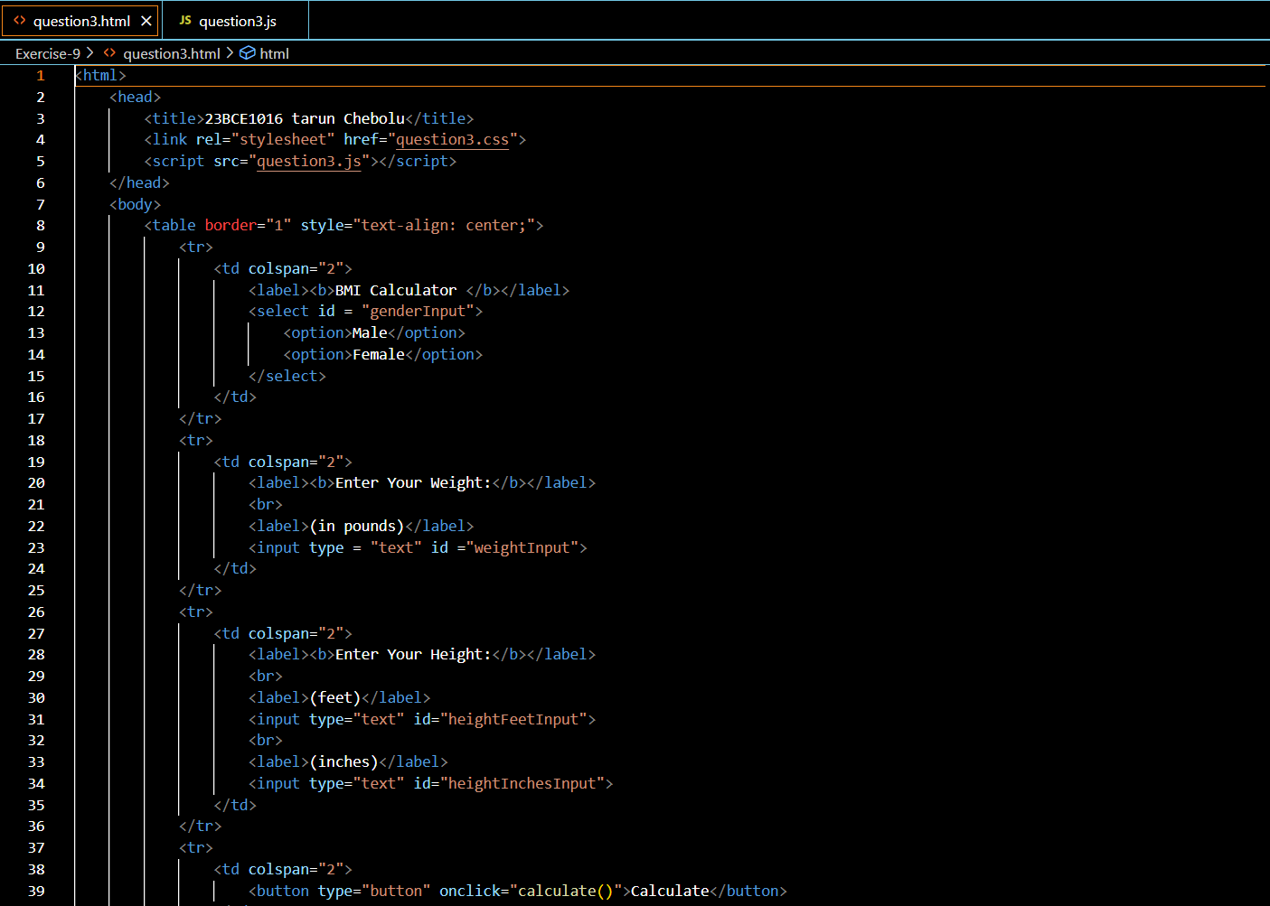

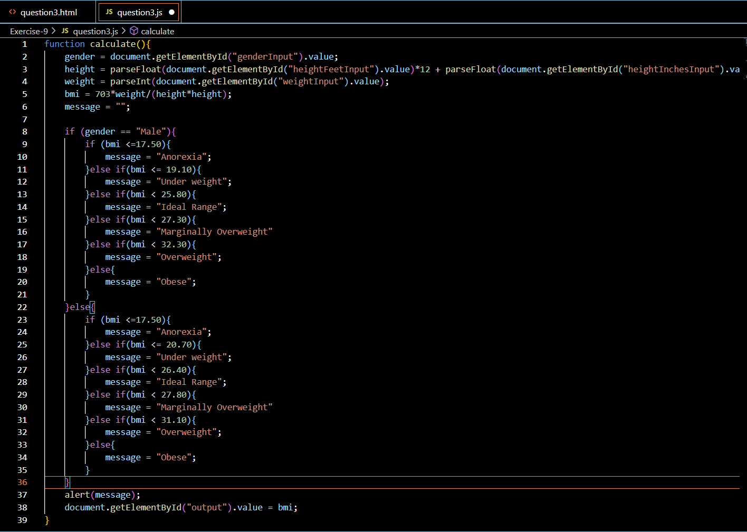

OUTPUT

